FINAL REPORT

Project Title :
Electric Motor Temperature Prediction Using Machine Learning

College Name :
Annamacharya Institute of Technology and Sciences, Tirupati

Team Details:
Team ID : LTVIP2026TMIDS42111
Name |  | Role
T. Sankar Reddy |  | Team Leader
P. Chandrasekhar Reddy |  | Team Member 1
R. Kalyan |  | Team Member 2

Platform & Technologies
- Platform: Machine Learning Development Environment
- Technology Stack:
  - Python Programming Language
  - NumPy and Pandas for Data Processing
  - Scikit-learn for Machine Learning Models
  - Matplotlib & Seaborn for Data Visualization
  - Jupyter Notebook / Google Colab for Development
  - CSV-based Sensor Dataset

Project Overview
The Motor Temperature Prediction System is designed to predict the operating temperature of industrial motors using machine learning techniques. The system analyzes historical sensor data such as voltage, current, torque, speed, and ambient conditions to accurately forecast motor temperature. This predictive approach helps industries shift from reactive maintenance to predictive maintenance, reducing unexpected failures, downtime, and maintenance costs while improving overall operational efficiency.

Problem Statement
Industrial motors are critical components in manufacturing and automation systems. However, traditional temperature monitoring systems rely on fixed thresholds and manual inspections, which lead to:
- Sudden motor overheating and unexpected failures
- Increased maintenance costs and operational downtime
- Lack of early warning mechanisms
- Inefficient use of historical operational data
- Reduced equipment lifespan
There is a need for an intelligent system capable of predicting motor temperature in advance to enable timely preventive actions.

Proposed Solution
The proposed solution is a machine learning–based motor temperature prediction system that:
- Uses historical motor sensor data to train predictive models
- Accurately predicts motor temperature under varying operating conditions
- Generates early warnings when temperature exceeds safe limits
- Supports predictive maintenance and failure prevention
- Improves equipment reliability, safety, and efficiency
The system enables industries to make data-driven maintenance decisions.

Methodology
The project was implemented following a structured machine learning development framework, ensuring systematic progress and validation.
1. Requirement Gathering
- Identified industrial motor monitoring challenges
- Analyzed operational and sensor data requirements
- Defined functional and non-functional requirements
2. System Design
- Designed data flow architecture for sensor data processing
- Selected appropriate machine learning algorithms
- Defined input features and output prediction parameters
3. Implementation
- Collected and preprocessed motor sensor data
- Performed feature selection and normalization
- Trained machine learning models for temperature prediction
- Evaluated model performance using regression metrics
4. Testing & Validation
- Conducted functional testing on data input and predictions
- Performed performance testing using MAE, MSE, and RMSE
- Validated prediction accuracy against actual temperature values
5. Deployment & Presentation
- Finalized trained machine learning model
- Prepared visualizations and prediction outputs
- Documented system workflow and results for presentation

Future Scope
The Motor Temperature Prediction system can be further enhanced by:
- Integration with real-time IoT sensor networks
- Deployment as a real-time monitoring dashboard
- Use of deep learning models for higher prediction accuracy
- AI-driven automated maintenance scheduling
- Integration with industrial control systems

References
- Scikit-learn Machine Learning Documentation
- Python Official Documentation
- Research Papers on Predictive Maintenance
- Industrial Motor Sensor Datasets
- Machine Learning and Data Analytics Textbooks

ACKNOWLEDGEMENT

I would like to express my sincere gratitude to my internship guide and project mentor for their continuous guidance, encouragement, and valuable suggestions throughout the completion of this project. Their technical expertise and support played a vital role in shaping the project successfully.
I am also thankful to the faculty members of my department for providing the necessary academic support and resources. Special thanks to my teammates for their cooperation, coordination, and teamwork during every phase of the project. Lastly, I would like to thank my institution for providing the opportunity to undertake this internship and gain practical exposure to real-world problem-solving using machine learning techniques.

ABSTRACT

Industrial motors are critical assets in manufacturing, automation, and power systems. Motor overheating is one of the leading causes of equipment failure, resulting in unplanned downtime, increased maintenance costs, and reduced operational efficiency. Traditional motor monitoring systems primarily rely on fixed threshold-based alarms and periodic manual inspections, which often fail to detect early warning signs of overheating.
This project presents a Machine Learning–based Motor Temperature Prediction System that utilizes historical sensor data to predict motor temperature accurately under varying operating conditions. By analyzing parameters such as current, voltage, torque, rotational speed, and ambient temperature, the system learns complex relationships that influence motor thermal behavior. The proposed solution enables predictive maintenance by forecasting potential overheating conditions before they occur, thereby improving reliability, safety, and efficiency.
The project follows a structured development approach covering ideation, requirement analysis, system design, project planning, implementation, testing, validation, and completion. The results demonstrate that machine learning techniques can significantly enhance industrial motor monitoring and maintenance strategies.

CHAPTER 1 - INTRODUCTION

1.1 Background
Electric motors are widely used in industries such as manufacturing, transportation, energy, and automation. Continuous operation under varying loads and environmental conditions causes motors to generate heat. If not properly managed, excessive temperature rise can lead to insulation degradation, bearing failure, and complete motor breakdown.
Traditional monitoring methods rely on threshold alarms or periodic inspections, which are reactive rather than predictive. With the advancement of data analytics and machine learning, it is now possible to leverage historical sensor data to predict motor behavior and prevent failures before they occur.

1.2 Motivation
The motivation behind this project is to:
- Reduce unexpected motor failures
- Improve maintenance planning
- Enhance equipment lifespan
- Apply machine learning to a real-world industrial problem
Predictive maintenance using machine learning offers a cost-effective and intelligent alternative to traditional maintenance practices.

1.3 Objectives
The primary objectives of this project are:
- To analyze motor sensor data
- To build a machine learning model for temperature prediction
- To evaluate model accuracy and performance
- To enable early warning for overheating conditions
CHAPTER 2 - IDEATION PHASE

2.1 Overview of Ideation Phase
The ideation phase focuses on understanding the problem domain, identifying key challenges, exploring potential solutions, and defining a clear project direction. This phase establishes the conceptual foundation of the Motor Temperature Prediction system.

2.2 Brainstorming
Brainstorming sessions were conducted to explore various industrial challenges related to motor operation and maintenance. Several issues such as unexpected motor failure, overheating, inefficient maintenance schedules, and lack of predictive insight were identified.
Traditional systems were found to be:
- Reactive in nature
- Dependent on fixed thresholds
- Unable to utilize historical data effectively
Machine learning emerged as a promising solution due to its ability to learn patterns from data and make accurate predictions under dynamic conditions.

2.3 Empathy Mapping
Empathy mapping was used to understand the needs of stakeholders such as:
- Maintenance engineers
- Plant operators
- Operations managers
Their primary concerns included:
- Sudden motor failures
- High maintenance costs
- Safety risks
- Lack of early warning systems
This analysis highlighted the need for an intelligent and predictive monitoring system.

2.4 Problem Statement
To design and develop a machine learning–based system capable of predicting motor temperature accurately using historical sensor data, thereby enabling predictive maintenance, reducing downtime, and improving operational efficiency.

2.5 Ideation Outcome
The ideation phase concluded with:
- Clear problem definition
- Identified stakeholders
- Defined project scope
- Selection of machine learning as the core solution

CHAPTER 3 – REQUIREMENT ANALYSIS PHASE

3.1 Introduction to Requirement Analysis
Requirement Analysis is one of the most critical phases in the software and machine learning development lifecycle. In the Motor Temperature Prediction project, this phase focuses on translating the problem identified during the ideation phase into well-defined, structured, and implementable system requirements.
The objective of this phase is to clearly understand:
- What the system should do
- How the system should behave
- What constraints the system must operate under
A well-executed requirement analysis ensures that the final system meets user expectations, functions reliably, and aligns with real-world industrial needs.

3.2 Customer Journey Map
3.2.1 Overview
A Customer Journey Map visually and descriptively represents the interaction between users and the proposed system across different stages. For the Motor Temperature Prediction system, the customer journey helps in understanding how maintenance engineers and operators interact with the system from data monitoring to decision-making.
This mapping ensures that the system is user-centric and addresses real operational challenges.

3.2.2 Stakeholders Involved
The primary stakeholders identified in this project include:
- Maintenance Engineers
- Plant Operators
- Production Managers
- System Administrators
Each stakeholder interacts with the system differently but shares the common objective of preventing motor failure.
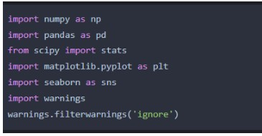

3.2.3 Journey Stage 1: Motor Operation Monitoring
At this stage, the motor operates under normal or varying load conditions.
User Actions
- Monitor motor performance parameters
- Observe operational trends
- Check historical records
Challenges Faced
- Manual monitoring is time-consuming
- Raw data lacks predictive insights
- Difficult to detect early overheating signs
System Role
- Continuously collects sensor data
- Stores historical operational data
- Displays parameter trends visually

3.2.4 Journey Stage 2: Temperature Prediction
Once sufficient data is available, the system applies machine learning algorithms to predict motor temperature.
User Expectations
- Accurate temperature prediction
- Early detection of abnormal behavior
- Minimal false alerts
System Actions
- Preprocesses incoming data
- Applies trained ML models
- Generates predicted temperature values
This stage is the core value addition of the system, transforming raw data into actionable intelligence.

3.2.5 Journey Stage 3: Alert Generation and Decision Making
When predicted temperature exceeds predefined safety thresholds:
User Actions
- Receives alerts or warnings
- Evaluates severity of the issue
- Decides maintenance or load reduction
System Capabilities
- Early warning notifications
- Clear visualization of temperature trends
- Support for informed decision-making

3.2.6 Journey Stage 4: Maintenance and Optimization
Based on system insights:
User Actions
- Schedule preventive maintenance
- Optimize motor operating conditions
- Reduce load if required
Outcome
- Reduced downtime
- Extended motor lifespan
- Improved safety and efficiency
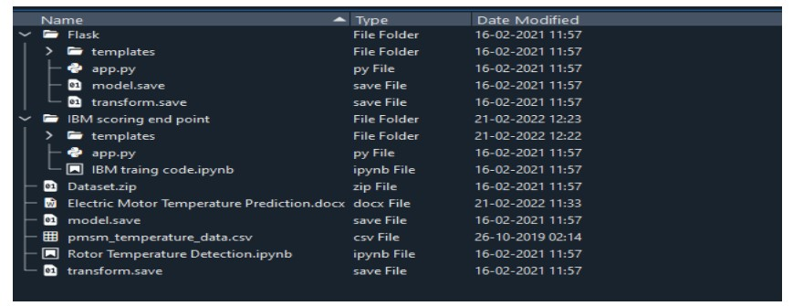

3.3 Data Flow Diagram (DFD)
3.3.1 Purpose of Data Flow Diagram
The Data Flow Diagram illustrates how data moves through the Motor Temperature Prediction system. It helps in understanding data sources, processing stages, storage mechanisms, and outputs.

3.3.2 Level 0 DFD (Context Diagram)
At the highest level, the system interacts with:
External Entities
- Motor Sensors
- Users (Engineers, Operators)
Process
- Motor Temperature Prediction System
Data Flow
- Sensor data → System
- Predicted temperature & alerts → Users
This level provides a high-level overview of system interaction.

3.3.3 Level 1 DFD
The system is further decomposed into sub-processes:
Process 1: Data Acquisition
- Collects motor parameters
- Handles real-time and historical data
Process 2: Data Preprocessing
- Removes noise and missing values
- Normalizes sensor data
- Prepares features for model input
Process 3: Model Prediction
- Applies machine learning algorithms
- Predicts motor temperature
Process 4: Output and Visualization
- Displays predictions
- Generates alerts and reports

3.4 Functional Requirements
Functional requirements define what the system must do.
3.4.1 Identified Functional Requirements
- The system shall accept sensor data as input
- The system shall preprocess raw data
- The system shall predict motor temperature
- The system shall store historical data
- The system shall generate alerts
- The system shall display prediction results
These requirements ensure complete system functionality.
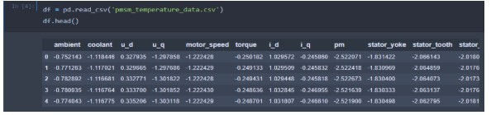

3.5 Non-Functional Requirements
Non-functional requirements define system quality attributes.
3.5.1 Performance Requirements
- Low latency prediction
- High accuracy
3.5.2 Reliability Requirements
- Fault-tolerant data handling
- Consistent prediction results
3.5.3 Scalability Requirements
- Support multiple motors
- Handle increasing data volume
3.5.4 Usability Requirements
- Easy-to-use interface
- Minimal training required

3.6 Technology Stack
3.6.1 Programming Language
- Python due to its rich ML ecosystem
3.6.2 Libraries and Tools
- NumPy and Pandas for data processing
- Scikit-learn for ML models
- Matplotlib and Seaborn for visualization
3.6.3 Development Environment
- Jupyter Notebook / Google Colab
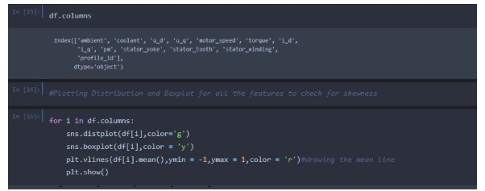

3.7 Requirement Analysis Outcome
The Requirement Analysis Phase resulted in:
- Clear system requirements
- Defined data flow
- Identified technology stack
- Strong foundation for system design

CHAPTER 4 - PROJECT DESIGN PHASE

4.1 Introduction to Project Design Phase
The Project Design Phase is a crucial stage in the development of the Motor Temperature Prediction Using Machine Learning system. This phase focuses on transforming the requirements identified during the Requirement Analysis Phase into a structured and technically feasible system design. The design phase serves as a bridge between conceptual planning and actual system implementation.
In this project, the design phase emphasizes identifying the best-fit solution for the problem, analyzing different solution approaches, defining the proposed solution in detail, and designing the overall system architecture. A well-defined design ensures scalability, reliability, maintainability, and accurate performance of the predictive model.

4.2 Problem–Solution Fit
4.2.1 Understanding the Problem Context
Electric motors operate under diverse conditions such as fluctuating loads, variable ambient temperatures, and continuous operational cycles. These variations directly influence motor temperature. Traditional motor monitoring systems rely on fixed threshold-based alarms that react only after a critical temperature level is reached. Such reactive systems fail to provide early warnings, often leading to unexpected failures and costly downtime.
The core problem addressed in this project is the lack of predictive capability in existing motor temperature monitoring systems.

4.2.2 Identifying the Right Solution Approach
To ensure a strong problem–solution fit, various approaches were evaluated, including:
- Rule-based systems
- Statistical regression models
- Physics-based thermal models
- Machine learning–based predictive models
Rule-based and physics-based approaches were found to be rigid and difficult to adapt to changing operating conditions. Statistical models lacked the ability to capture complex nonlinear relationships between motor parameters.
Machine learning techniques, on the other hand, demonstrated the ability to:
- Learn patterns from historical data
- Adapt to changing motor behavior
- Handle multivariate and nonlinear relationships
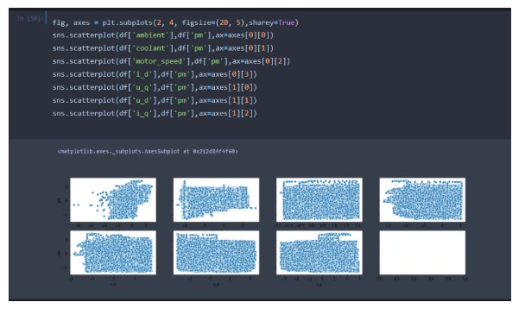

4.2.3 Justification of Machine Learning as the Solution
Machine learning provides a data-driven approach that aligns perfectly with the problem characteristics. The availability of large volumes of historical motor sensor data makes ML a suitable choice. The model continuously improves as more data becomes available, ensuring long-term reliability and adaptability.
Thus, a strong alignment was established between the problem of motor overheating prediction and the proposed machine learning–based solution.

4.3 Problem Solution Analysis
4.3.1 Analysis of Existing Systems
Existing motor temperature monitoring systems generally:
- Monitor temperature sensors in real time
- Trigger alarms when thresholds are exceeded
- Depend heavily on manual intervention
Limitations of these systems include:
- Late detection of faults
- High false alarm rates
- No predictive insight
These shortcomings highlight the need for a more intelligent solution.

4.3.2 Analysis of Proposed Predictive Approach
The proposed approach uses historical sensor data such as:
- Motor current
- Voltage
- Speed
- Torque
- Ambient temperature
By analyzing these parameters collectively, the machine learning model identifies patterns that influence temperature rise.
Key advantages of this approach include:
- Early detection of abnormal thermal behavior
- Reduced dependency on manual monitoring
- Improved maintenance planning

4.3.3 Feasibility Analysis
Technical Feasibility
Modern machine learning libraries and computational tools make the implementation technically feasible. Python-based ML frameworks provide robust support for model training, validation, and deployment.
Operational Feasibility
The system can be integrated into existing motor monitoring workflows with minimal disruption.
Economic Feasibility
Predictive maintenance reduces maintenance costs, downtime losses, and equipment replacement expenses.

4.4 Proposed Solution
4.4.1 Overview of the Proposed System
The proposed system is a Machine Learning–based Motor Temperature Prediction System that predicts future motor temperature values using historical and real-time sensor data. The system enables early warning alerts and supports proactive maintenance strategies.

4.4.2 Functional Description
The system performs the following key functions:
- Data collection from motor sensors
- Data preprocessing and cleaning
- Feature extraction and normalization
- Machine learning model training
- Temperature prediction
- Alert generation and visualization
Each function is designed to work seamlessly within the overall system.

4.4.3 Machine Learning Model Selection
Several machine learning algorithms were evaluated, including:
- Linear Regression
- Decision Trees
- Random Forest
- Support Vector Regression
After analysis, ensemble-based models were preferred due to:
- Higher accuracy
- Better generalization
- Reduced overfitting
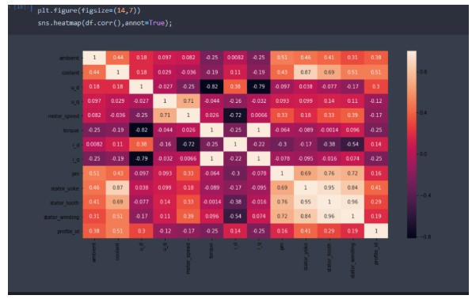

4.4.4 Expected Outcomes
The proposed solution is expected to:
- Predict motor temperature accurately
- Reduce unexpected motor failures
- Improve equipment reliability
- Enable data-driven maintenance decisions

4.5 Solution Architecture
4.5.1 Architectural Overview
The system architecture is designed in a modular manner to ensure scalability and maintainability. Each component performs a specific function and communicates with other components through well-defined interfaces.

4.5.2 System Components
1. Data Acquisition Layer
This layer collects sensor data from motors, including electrical and environmental parameters.
2. Data Processing Layer
This layer handles:
- Data cleaning
- Missing value handling
- Noise reduction
- Feature scaling

3. Machine Learning Layer
This layer includes:
- Model training module
- Prediction engine
- Model evaluation module
It is responsible for learning patterns and generating temperature predictions.

4. Visualization and Alert Layer
This layer:
- Displays temperature trends
- Shows prediction results
- Generates alerts for abnormal conditions
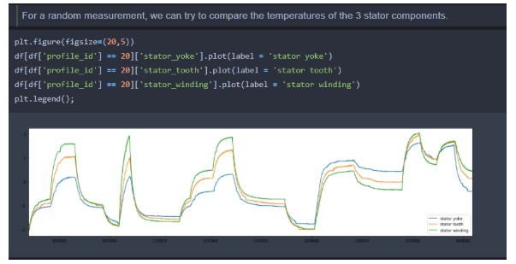

4.5.3 Data Flow in Architecture
- Sensor data enters the system
- Data is processed and normalized
- ML model predicts temperature
- Results are stored and visualized
- Alerts are triggered if thresholds are exceeded

4.5.4 Design Considerations
Key design considerations include:
- Accuracy and reliability
- Scalability for multiple motors
- Low-latency predictions
- Ease of integration

4.6 Design Phase Outcome
The Project Design Phase successfully delivered:
- A clear problem–solution alignment
- A technically feasible solution
- A modular system architecture
- A strong foundation for implementation
This phase ensures that the system is well-prepared for development and deployment in real-world industrial environments.

CHAPTER 5 - PROJECT PLANNING PHASE

5.1 Introduction to Project Planning Phase
The Project Planning Phase plays a vital role in ensuring the successful execution of the Motor Temperature Prediction Using Machine Learning project. This phase focuses on defining a structured roadmap that guides the project from design to completion. Proper planning helps in minimizing risks, optimizing resource utilization, maintaining timelines, and ensuring that all project objectives are achieved efficiently.
In this project, the planning phase includes defining project scope, setting milestones, allocating resources, identifying risks, and preparing a systematic project plan template that aligns with academic internship requirements and real-world development practices.

5.2 Importance of Project Planning
Project planning is essential for the following reasons:
- Provides a clear direction for project execution
- Helps in managing time and resources effectively
- Reduces uncertainties and risks
- Ensures smooth coordination between project phases
- Enables progress tracking and performance evaluation
Without proper planning, even technically strong projects may fail due to delays, scope creep, or miscommunication.

5.3 Project Scope Definition
5.3.1 In-Scope Activities
The scope of the Motor Temperature Prediction project includes:
- Data collection and preprocessing
- Feature selection and normalization
- Machine learning model development
- Model training and validation
- Performance evaluation
- Prediction visualization
- Alert generation mechanism
These activities directly contribute to achieving the project objectives.
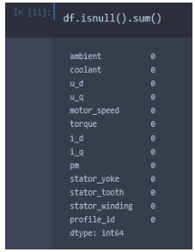

5.3.2 Out-of-Scope Activities
To maintain focus and feasibility, the following activities were considered out of scope:
- Real-time hardware sensor integration
- Deployment on large-scale industrial cloud platforms
- Mobile or web-based application development
- Integration with enterprise maintenance systems

5.4 Project Planning Template
The project planning template provides a structured framework to manage and monitor project progress. It includes phases, tasks, timelines, deliverables, and responsibilities.

5.4.1 Project Phases and Tasks
Phase 1: Problem Understanding and Ideation
- Understanding industrial motor operations
- Identifying overheating challenges
- Finalizing project problem statement
Phase 2: Requirement Analysis
- Identifying system requirements
- Creating data flow diagrams
- Selecting technology stack
Phase 3: System Design
- Defining solution architecture
- Selecting ML algorithms
- Designing data processing flow
Phase 4: Implementation
- Coding data preprocessing modules
- Training ML models
- Implementing prediction logic
Phase 5: Testing and Validation
- Functional testing
- Performance testing
- Model accuracy evaluation

Phase 6: Documentation and Completion
- Preparing final report
- Creating presentation materials
- Project review and submission

5.4.2 Timeline Planning
A realistic timeline was created to ensure timely completion of the project. Each phase was allocated sufficient time based on complexity and dependencies.
Phase | Description | Duration
Ideation | Problem identification | 1 Week
Requirement Analysis | Requirement definition | 1 Week
Design | System architecture | 1 Week
Implementation | Model development | 2 Weeks
Testing | Validation & evaluation | 1 Week
Documentation | Final report | 1 Week
This timeline ensured balanced workload distribution.

5.5 Resource Planning
5.5.1 Human Resources
The project required the following roles:
- Project Developer / Intern
- Project Guide / Mentor
- Academic Reviewer
Each role contributed to different stages of the project lifecycle.

5.5.2 Software Resources
The following software tools were planned and utilized:
- Python programming language
- Jupyter Notebook / Google Colab
- Scikit-learn for ML modeling
- Pandas and NumPy for data handling
- Matplotlib for visualization
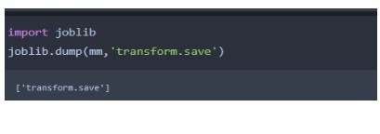

5.5.3 Hardware Resources
- Personal computer or laptop
- Adequate RAM and processor for ML training

5.6 Risk Management Plan
5.6.1 Risk Identification
Potential risks identified during planning include:
- Poor data quality
- Overfitting or underfitting of ML models
- Time constraints
- Computational limitations

5.6.2 Risk Mitigation Strategies
Risk | Mitigation Strategy
Data inconsistency | Data cleaning and preprocessing
Model overfitting | Cross-validation techniques
Time delays | Buffer time allocation
Performance issues | Algorithm optimization

5.7 Milestone Planning
Key milestones were defined to track progress:
- Completion of requirement analysis
- Finalization of system design
- Successful model training
- Performance validation completion
- Final documentation submission
Milestone tracking ensured timely identification of deviations and corrective actions.
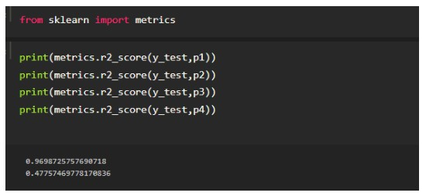

5.8 Quality Management Plan
To ensure high-quality outcomes, the following quality measures were planned:
- Regular code reviews
- Model performance evaluation metrics
- Validation against requirements
- Documentation accuracy checks
Quality assurance was embedded throughout the project lifecycle.

5.9 Communication Plan
Effective communication was planned through:
- Regular discussions with project guide
- Weekly progress updates
- Feedback incorporation
Clear communication helped in aligning project outcomes with expectations.

5.10 Project Planning Phase Outcome
The Project Planning Phase resulted in:
- A well-defined project roadmap
- Clearly assigned tasks and timelines
- Identified risks and mitigation strategies
- Efficient resource utilization plan
This phase laid a strong foundation for smooth project execution and successful completion.
CHAPTER 6 - PROJECT IMPLEMENTATION PHASE

6.1 Introduction to Project Implementation Phase
The Project Implementation Phase is the stage where the conceptual designs and plans developed in earlier phases are transformed into a working system. In the Motor Temperature Prediction Using Machine Learning project, this phase focuses on building the machine learning pipeline, implementing data preprocessing techniques, training predictive models, and generating meaningful outputs.
This phase involves practical application of theoretical knowledge related to data science, machine learning algorithms, and software development. Careful implementation ensures that the system performs accurately, efficiently, and reliably in predicting motor temperature.

6.2 Implementation Environment Setup
6.2.1 Development Environment
The implementation was carried out using a Python-based development environment due to its extensive support for data analytics and machine learning.
The following environments were used:
- Jupyter Notebook for interactive development
- Google Colab for computational support and experimentation
These platforms provided flexibility, visualization capabilities, and easy debugging during development.

6.2.2 Software Tools and Libraries
The implementation utilized the following libraries:
- NumPy: For numerical computations
- Pandas: For data manipulation and analysis
- Scikit-learn: For machine learning model implementation
- Matplotlib: For data visualization
- Seaborn: For advanced graphical representation
Each library played a critical role in building a robust and efficient prediction system.

6.3 Data Collection and Understanding
6.3.1 Data Source Description
The dataset used in this project consists of historical motor operation data collected from sensors. The data includes multiple parameters that influence motor temperature, such as:
- Motor current
- Voltage
- Torque
- Rotational speed
- Ambient temperature
- Motor temperature (target variable)
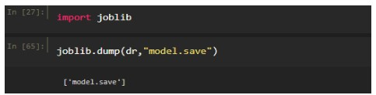

6.3.2 Data Characteristics
The dataset contains:
- Continuous numerical values
- Time-dependent observations
- Multivariate features
Understanding the nature of the dataset was essential to choose appropriate preprocessing and modeling techniques.

6.4 Data Preprocessing
6.4.1 Importance of Data Preprocessing
Raw sensor data often contains noise, missing values, and inconsistencies. Data preprocessing is crucial to ensure that the machine learning model receives clean, meaningful, and well-structured input.


6.4.2 Handling Missing Values
Missing values were identified and handled using:
- Mean or median imputation
- Removal of incomplete records where necessary
This step improved data consistency and model reliability.

6.4.3 Noise Reduction and Outlier Handling
Outliers were detected using:
- Statistical methods
- Visualization techniques such as box plots
Outliers that significantly affected model performance were treated or removed.

6.4.4 Feature Scaling and Normalization
Since the dataset contained parameters with different ranges, feature scaling was applied using:
- Standardization
- Min–Max normalization
This step ensured uniform contribution of features during model training.

6.5 Feature Selection and Engineering
6.5.1 Feature Selection
Relevant features influencing motor temperature were selected based on:
- Domain knowledge
- Correlation analysis
- Model performance impact
This reduced model complexity and improved accuracy.

6.5.2 Feature Engineering
Additional features were derived from existing data to enhance predictive power. Feature engineering helped capture hidden relationships between motor parameters and temperature behavior.

6.6 Machine Learning Model Development
6.6.1 Model Selection
Multiple machine learning algorithms were implemented and evaluated, including:
- Linear Regression
- Decision Tree Regression
- Random Forest Regression
- Support Vector Regression
These models were chosen based on their ability to handle regression problems and nonlinear relationships.
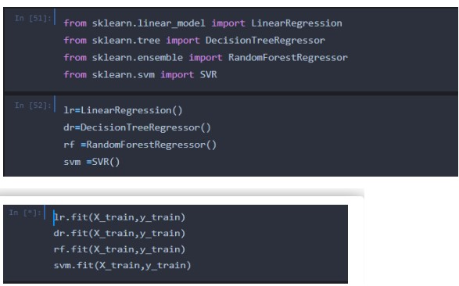

6.6.2 Model Training
The dataset was split into:
- Training set
- Testing set
The training set was used to train the models, while the testing set evaluated generalization performance.

6.6.3 Hyperparameter Tuning
Hyperparameters were optimized using:
- Grid search
- Cross-validation
This process helped in improving model accuracy and preventing overfitting.

6.7 Model Evaluation
6.7.1 Evaluation Metrics
The following metrics were used to evaluate model performance:
- Mean Absolute Error (MAE)
- Mean Squared Error (MSE)
- Root Mean Squared Error (RMSE)
- R-squared value
These metrics provided quantitative insight into prediction accuracy.

6.7.2 Model Comparison
The performance of all models was compared, and the model with the best balance of accuracy and stability was selected as the final prediction model.
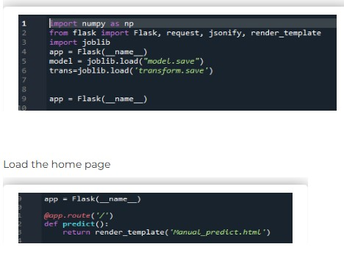

6.8 Prediction and Output Generation
6.8.1 Temperature Prediction
The trained model was used to predict motor temperature for unseen data. Predictions closely matched actual temperature values, demonstrating the effectiveness of the approach.

6.8.2 Visualization of Results
Prediction results were visualized using:
- Line graphs
- Scatter plots
These visualizations helped users understand temperature trends and potential overheating risks.

6.9 Alert Mechanism Implementation
An alert mechanism was implemented to notify users when predicted temperature exceeded safe operating limits. This feature supports proactive maintenance and operational safety.

6.10 Implementation Challenges and Solutions
6.10.1 Challenges Faced
- Data inconsistency
- Model overfitting
- Computational limitations

6.10.2 Solutions Implemented
- Improved preprocessing techniques
- Regularization and validation
- Efficient algorithm selection

6.11 Implementation Phase Outcome
The Project Implementation Phase successfully delivered:
- A fully functional machine learning model
- Accurate temperature prediction capability
- Visual and alert-based outputs
- A system ready for testing and validation
This phase transformed theoretical concepts into a practical predictive maintenance solution.

CHAPTER 7 - TESTING AND VALIDATION PHASE

7.1 Introduction to Testing and Validation Phase
The Testing and Validation Phase is a critical stage in the Motor Temperature Prediction Using Machine Learning project, as it ensures that the implemented system performs accurately, reliably, and in accordance with the defined requirements. This phase focuses on verifying the correctness of the system’s functionality and validating the effectiveness of the machine learning model under different operating conditions.
Testing ensures that each component of the system behaves as expected, while validation confirms that the overall system meets user needs and real-world industrial requirements. A systematic testing and validation approach helps in identifying defects, improving model performance, and enhancing system robustness.

7.2 Objectives of Testing and Validation
The primary objectives of this phase are:
- To verify that all functional requirements are met
- To evaluate the performance of the machine learning model
- To ensure prediction accuracy and reliability
- To validate system behavior under different scenarios
- To identify and rectify errors or inconsistencies
Achieving these objectives ensures the readiness of the system for practical usage.

7.3 Testing Strategy
A structured testing strategy was adopted to cover both functional and performance aspects of the system. The strategy includes:
- Functional Testing
- Performance Testing
- Model Validation
- Error and Exception Handling Tests
Each testing category targets a specific aspect of system quality.

7.4 Functional Testing
7.4.1 Overview of Functional Testing
Functional testing focuses on verifying whether the system performs all intended functions correctly. It ensures that inputs are processed accurately and that outputs match expected results.

7.4.2 Functional Test Scenarios
The following key functional test scenarios were identified and executed:
Test Case 1: Data Input Validation
- Objective: Verify acceptance of valid sensor data
- Input: Motor parameters (current, voltage, speed, torque)
- Expected Result: Data accepted and stored correctly

Test Case 2: Data Preprocessing
- Objective: Verify data cleaning and normalization
- Input: Raw sensor data with missing values
- Expected Result: Cleaned and normalized dataset

Test Case 3: Model Prediction
- Objective: Verify temperature prediction accuracy
- Input: Preprocessed test data
- Expected Result: Accurate temperature predictions

Test Case 4: Alert Generation
- Objective: Verify alert triggering mechanism
- Condition: Predicted temperature exceeds threshold
- Expected Result: Alert notification generated
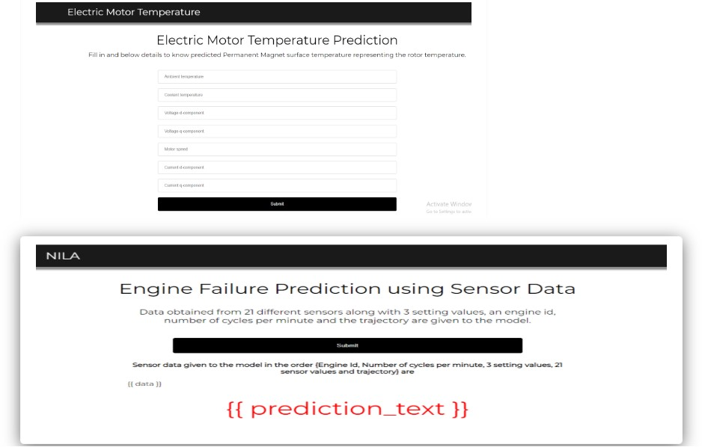

7.4.3 Functional Testing Outcome
All functional tests were executed successfully, confirming that:
- System modules work as intended
- Data flows correctly across components
- Alerts are generated accurately

7.5 Performance Testing
7.5.1 Purpose of Performance Testing
Performance testing evaluates how efficiently the system performs under various conditions. It focuses on response time, prediction accuracy, and system stability.

7.5.2 Performance Metrics
The following performance metrics were used:
- Mean Absolute Error (MAE)
- Mean Squared Error (MSE)
- Root Mean Squared Error (RMSE)
- R-squared Score
These metrics quantify the deviation between predicted and actual temperature values.

7.5.3 Performance Evaluation Results
The trained machine learning model demonstrated:
- High prediction accuracy
- Low error values
- Consistent performance across datasets
This confirms the effectiveness of the predictive approach.

7.6 Model Validation
7.6.1 Validation Techniques Used
To ensure generalization capability, the following validation techniques were applied:
- Train-test split validation
- Cross-validation
- Comparison with baseline models
These techniques helped in detecting overfitting and underfitting.

7.6.2 Validation Results
Validation results showed that the model:
- Generalizes well to unseen data
- Maintains accuracy across different operating conditions
- Performs better than traditional threshold-based methods
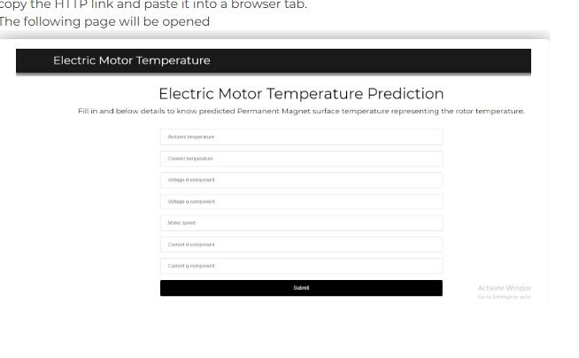

7.7 Error Handling and Robustness Testing
7.7.1 Error Scenarios Tested
- Missing sensor values
- Invalid input ranges
- Sudden data spikes

7.7.2 System Response
The system handled errors gracefully by:
- Ignoring or correcting invalid inputs
- Preventing system crashes
- Maintaining prediction stability
This enhanced system robustness and reliability.

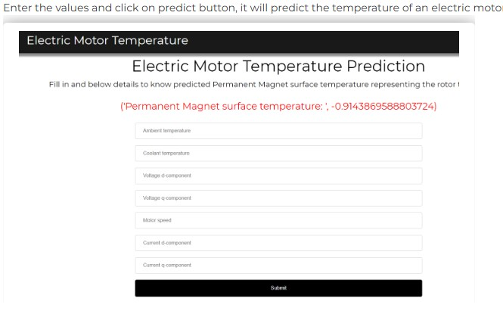

7.8 User Acceptance Validation
User acceptance validation was conducted by evaluating whether the system meets the expectations of maintenance engineers and operators.
Key validation points include:
- Ease of understanding predictions
- Clarity of alerts
- Usefulness of insights for maintenance planning
Feedback confirmed that the system supports informed decision-making.

7.9 Limitations Identified During Testing
Despite strong performance, certain limitations were observed:
- Dependency on data quality
- Reduced accuracy for extreme operating conditions
- Absence of real-time sensor integration
These limitations provide direction for future enhancements.

7.10 Testing and Validation Phase Outcome
The Testing and Validation Phase successfully confirmed that:
- The system meets all functional requirements
- The machine learning model performs accurately
- Predictions are reliable and consistent
- The system is ready for project completion
This phase ensures confidence in the system’s effectiveness and practical applicability.

